

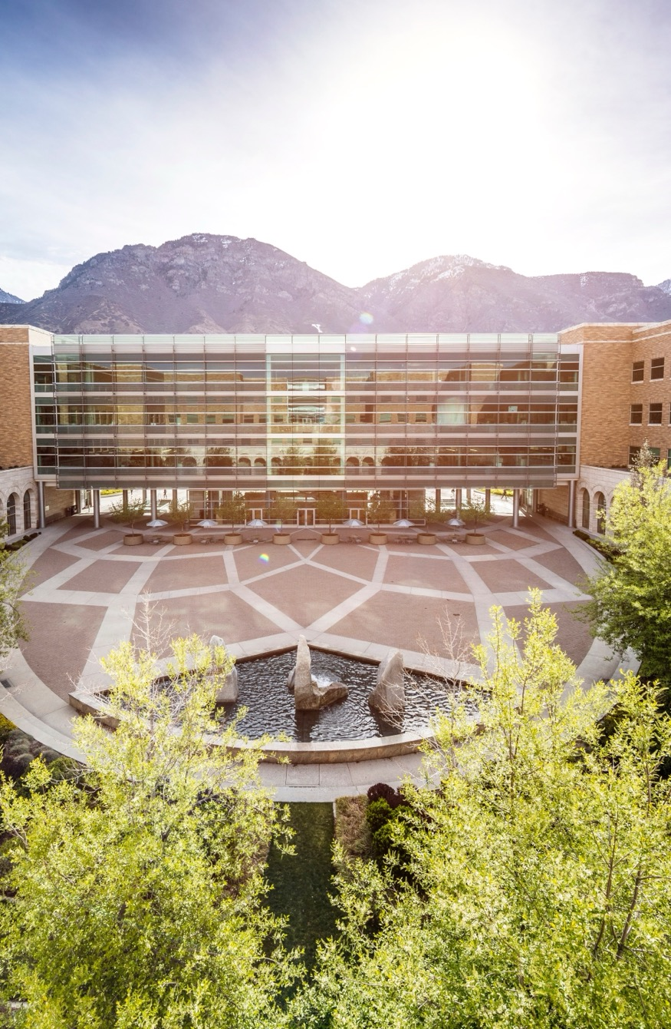

2025-26
GRADUATE STUDENT
HANDBOOK

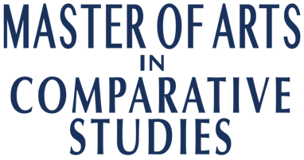

Dr. Kerry Soper
Department Chair

Dr. Mike Pope
Graduate Program Coordinator

Lisa Johnson
Graduate Program Manager

Please carefully read the information found within this handbook. Graduate students are responsible for meeting all deadlines and requirements found within. The handbook is updated each year and therefore should be carefully reviewed annually for changes to policies and procedures.


Student Handbook 2025-26
Table of Contents
INTRODUCTION 1
The Purpose of this Handbook 1
University Graduate School Policies 1
Important Offices 1

PROGRAM OVERVIEW 2
Learning Outcomes 2
Program Criteria 3

ADMISSION PREREQUISITES AND PROCEDURES 4
Prerequisites 4
Procedures 4

PROGRAM SUMMARY 5
Program of Study 5
Student Evaluations 6
Reading List and Written Examination 7
Thesis Prospectus 7
Writing the Thesis 8
Thesis Defense 9
Graduation 10

ADVISEMENT 11
Graduate Coordinator 11
Graduate Council for Comparative Studies for the 2024-2025 Academic Year 11
Graduate Program Manager 11
Thesis Committee and Thesis Committee Chair 12

RESOURCES 17
Harold B. Lee Library (HBLL) 17
Editing Help 18
Publishing 18

CONFERENCES 18

INTRODUCTION

The Purpose of this Handbook
Brigham Young University’s Graduate Studies website (https://gradstudies.byu.edu/) and the Graduate Studies Policy Handbook will be helpful resources for you as you navigate your graduate studies. This handbook is provided by the Comparative Arts and Letters Department as a supplement to the Graduate Studies website. This handbook describes policies and procedures that are unique to our department’s graduate program and will help you understand the necessary procedures to graduate with a master’s degree in Comparative Studies. Your familiarity with these procedures will help you progress in a timely manner through the program. It is your responsibility to be aware of the program requirements. Students are encouraged to be proactive and discuss any potential problems, concerns, or special circumstances with their Graduate Committee Chair, the Graduate Program Coordinator, or Graduate Program Manager.

The department makes every effort to ensure the accuracy of the contents of this handbook but reserves the right to make changes at any time and without notice. It is the student’s responsibility to comply with all University and Department policies and procedures and to satisfy all program and university requirements.

University Graduate School Policies
BYU’s Graduate School stipulates policies and timetables applicable to all departments. The student must be thoroughly familiar with these regulations and timetables. The graduate program manager will make every attempt to inform the student of deadlines and other requirements as these arise; but, the student holds primary responsibility to stay current with BYU Graduate Studies policies as outlined in their literature and in the BYU Graduate Policy Handbook. Please consult their website often for current information: https://gradstudies.byu.edu/

Graduate Studies Office
  - Keeps records of graduate students
  - Sends reports and statistics to the department and students
  - Adjudicates disputes or requests to extend deadlines, approve non-Graduate faculty, etc.

Important Offices
Dept of Comparative Arts & Letters | 3008 JFSB | 801-422-4448 | cal-pt@byu.edu
College of Humanities | 4002 JFSB | 801-422-4636 | humanities@byu.edu
Office of Graduate Studies | 105 FPH | 801-422-4091 | gradstudies@byu.edu
Enrollment Services | D-155 ASB | 801-422-4104
International Student and Scholar Services | 1351 WSC | 801-422-2695 | intloff@byu.edu

PROGRAM OVERVIEW

The term "humanities" (humanitas or studia humanitatis) refers to the study of human intellectual and artistic creativity, encompassing literature, history, philosophy, and the history and criticism of art, music, and dance. It involves critical study of intellectual history and aesthetics. The interdisciplinary fields within the humanities department—art history, classics, comparative literature, and interdisciplinary humanities—provide students with opportunities to pursue graduate education in the humanities, emphasizing foreign language skills, critical theory and practice, and scholarly rigor.
Comparative studies, distinct from general studies, focus on integration and interdisciplinarity. The Comparative Studies Master of Arts Program at Brigham Young University offers advanced training in interdisciplinary scholarship, particularly in humanities, classics, comparative literature, and art history. Students complete coursework outside the department, in areas like modern languages, history, philosophy, film and media arts, music, and dance, depending on faculty specialties and regional or period focuses. This program allows flexibility and breadth of study while maintaining rigor, making it suitable for those seeking a terminal M.A. degree or intending to pursue doctoral work in related fields.
The M.A. in Comparative Studies emphasizes individualized study. Each student collaborates with a faculty mentor to select from a variety of courses in Comparative Studies and other university departments, designing a personalized course of study that emphasizes a specific geographical area or period. These courses develop skills in teaching, research, and writing. Students also nominate committee members to guide their study through examinations and consultations.
The program encourages teaching and learning across disciplinary boundaries. It aims to emulate an institute of advanced study where scholars and students from various disciplines come together, benefiting from dynamic combinations and unexpected ideas. Graduate students learn analytical skills to develop interdisciplinary and comparative approaches to human culture, expanding their knowledge and providing research and writing opportunities.
The M.A. in Comparative Studies is typically completed within two academic years by full-time students, culminating in a thesis usually defended during the spring or summer term of the second year. If a student does not progress or withdraws for personal reasons, the department may request termination of their participation in the program.

Learning Outcomes
DISCIPLINARY PROFICIENCY WITH INTERDISCIPLINARY FOCUS
Emphasize advanced training in one discipline within the humanistic tradition, e.g. literature, art history, philosophy, music, dance, film, etc., demonstrate broad interdisciplinary knowledge of intellectual and artistic creativity.

ADVANCED RESEARCH AND SCHOLARLY WRITING
Produce scholarly writing, incorporating mastery of existing scholarship and analysis, revision, and oral presentation.

ADDITIONAL DISCIPLINARY PROFICIENCY
Demonstrate additional disciplinary proficiency either in a second foreign language (a 300 level course with a significant literary component, but not the same course(s) used for the general language requirement) or advanced coursework in a discipline other than literature (e.g., art history, history, philosophy, film, etc.). Graduate advisors must approve students' areas of emphasis.

EFFECTIVE CRITICAL AND ANALYTICAL THINKING
Demonstrate critical and analytical thinking through reading, classroom discussion, writing, and oral presentation.

Program Criteria

EXAMINATIONS

Graduate level courses in Comparative Studies (600-level courses) will include examinations constructed to measure students’ mastery of factual knowledge as well as to assess their analytical skills through mandatory essay components.

WRITING ASSIGNMENTS

Each graduate level course will include a minimum of 12-15 pages of writing combining formal analysis, evidence of critical thinking, and construction of persuasive arguments.

GRADES

B-average work is considered the minimum evidence of adequate skill set for graduation from the Comparative Studies Master’s program.

STUDENT EVALUATION

All students will be evaluated twice a year to determine the progress of each student. This is to help students stay on track to graduation.

READING LIST

Thorough acquaintance with the contents of a list of at least 21 works (including literature and other works deemed appropriate in consultation with a faculty advisor, subject to approval by the department’s graduate council), followed by a written examination to assess critical mastery of these works.

MASTER’S THESIS

Completion of a graduate-level master’s thesis and oral defense, typically interdisciplinary in nature, which is the culmination of extensive, focused research on one particular topic centered in the candidate’s area of emphasis. This thesis focuses on an original argument about the chosen topic, demonstrating both superior critical and analytical skills, as well as a thorough awareness of the topic’s historical, interpretive, and theoretical contexts.

ADMISSION PREREQUISITES AND PROCEDURES

Prerequisites
- Completion of a Baccalaureate degree in a humanistic discipline — e.g. interdisciplinary humanities, classics, comparative literature, English, foreign language, art history, history, music, or philosophy. Applicants from other disciplines may be considered, but they should inquire as to the appropriateness of their studies before applying. Contact the graduate coordinator.
- Proficiency in at least one foreign language of learning, demonstrated normally by completion with a grade of B or above of an upper-division literature course in the language (300 or above with a significant literature component—no conversation courses).

Procedures
Apply to the MA in Comparative Studies through the BYU Graduate Studies website. There is only one application for all graduate programs at BYU. You will specify the program when filling out the application.

- Provide official transcripts of all college-level coursework.
- GRE scores are no longer required for this program. You can bypass this section of the application.
- Submit a statement of intent outlining your preparation and aims for graduate study at BYU.
- Submit a writing sample of your own scholarly writing, i.e. a substantial paper demonstrating writing skills, research, analysis, and scholarly abilities.
- Submit a resume/cv that includes prior research, teaching experience, experiential learning, and/or internships
- Provide three letters of recommendation, preferably from persons acquainted with your scholarly performance and aptitude.
- Submit all parts of the BYU Graduate School Application and other requested materials by Feb 15th. (Regular departmental policy is to admit students for Fall semester only.)

Exceptions to procedure:
Applicants may submit a written request that transfer, senior, and post-baccalaureate studies credit be applied toward the MA in Comparative Studies according to the criteria set down and defined for such post-baccalaureate studies credit in the BYU Graduate Policy Handbook. This request will be reviewed, and approved or rejected, by the graduate council of the department. However, students intending this course of action are strongly cautioned that pursuing credit before admission to the Comparative Studies MA program in no way favors their application for admission to the program. If the written request is approved, the graduate coordinator, in consultation with the graduate council, will appoint a preliminary advisor to work with the applicant.

PROGRAM SUMMARY

Upon entering the program, each student will be assigned an advisor by the graduate council. The advisor’s principal tasks are to answer questions regarding the program, to consult about the student’s program of study, and to render what advice is needed in choosing specific courses to take. The graduate council acts as the student’s graduate committee until the thesis is begun.

Once the student has decided on a specific area of emphasis, in consultation with their advisor from the graduate council, the student forms a thesis committee consisting of a chair and two other members. A committee should be decided on and submitted on GRADPROG by the end of first semester. The thesis committee chair will serve subsequently as the student’s principal advisor.

If the student wishes to include a reader on the thesis committee who is not on the graduate faculty, a “Petition for Exception” needs to be submitted on the Grad Studies website HERE. Because such requests are sometimes denied, students should submit the petition early and not work with the faculty member until cleared. Graduate faculty from other departments frequently serve on a Comparative Studies thesis committee but they cannot chair a thesis committee.

Program of Study
Complete coursework of 33 credit hours with minimum GPA of 3.0 — a minimum 27 hrs in coursework, plus 6 thesis hours (CMPST 699R).
Graduate students must enroll in at least 6.0 credit hours per academic year (September through August) in order to maintain status as a graduate student. This is a university requirement; you will be dropped from your program if you do not meet this requirement; you will have to re-apply if less than 6 credits are taken in an academic year. This becomes particularly important when students have completed their course work and are working on their thesis/select project report.

  - Required coursework (18.0 credit hours)
  - CMPST 600, Introduction to Contemporary Critical Thought (3.0 hrs)
  - Required to register 1st semester (Fall)
  - CMPST 610, Colloquium in Comparative Studies (3.0 hrs)
  - Required to register 2nd semester (Winter)
  - 2 courses (minimum, 6.0+ hrs total) from Period, Area, Themes Studies—CMPST 620R, 625R, 630R, 640R, 660R, 670R
  - R numbered CMPST seminars encourage instructors and students wide range through the tradition from antiquity to the present. These courses are limited to graduate students only and are offered each Fall and Winter Semester. Instructors are chosen from the graduate faculty and topics are approved by the graduate council. Each CMPST seminar requires a research paper of a length and detail to serve as profitable and necessary experience toward the writing of the M.A. thesis.
  - These two additional CMPST 600-level classes can be taken any semester
  - 6 thesis hours, CMPST 699R (6.0 hrs)
  - The student must complete 6 thesis hours before graduation. Per BYU policy, graduate students must be enrolled for 2.0 credit hours during the semester or term of the thesis defense. It is advisable to reserve 2.0 thesis hours for the final semester or term.
  - Elective coursework (15.0 credit hours)
  - 5 courses (15.0 hrs total) in graduate-level coursework in comparative studies, humanities, classics, comparative literature, art history, musicology, history, philosophy, foreign language, history, film, or literature.
  - No religion or 300-level classes or below classes can be applied to the program of study. Any 400-level seminar in our department may be taken as a graduate course in consultation with the course instructor and the student’s academic advisor. Requirements for these courses will be modified commensurate with graduate level work.
  - No more than one directed readings course may be counted toward the MA degree in Comparative Studies.
    - Directed Readings: Students may opt to enroll in one directed reading course (CMPST 680R) to study material not covered in any regular graduate course. Variable credit in CMPST 680R allows a student to 1, 2, or 3 hrs in a given semester/term. A student may count a maximum of 3 credit hours of directed readings toward the degree. Because the faculty teach directed readings as an overload assignment, they are free to decline requests to teach them.

It is expected that students will develop advanced disciplinary proficiency in an academic field relevant to their academic goals. In consultation with their committee chair, students should plan a course of study that applies electives to best prepare the student for writing the thesis. Whereas some students may require advanced study in foreign languages, others will need further training in art history, philosophy, and so on. The key to success is communication with the committee chair early and then subsequently with other committee members and planning coursework in advance.

The Program of Study must be submitted on GradProg by the end of a student’s first semester.

Student Evaluations
Student evaluations will take place twice a year. The student’s committee will discuss the progress of each student. Each student is rated as making satisfactory, marginal, or unsatisfactory progress. Students are notified in writing of their progress.

Students making marginal or unsatisfactory progress are informed in writing:
- what they need to do to make satisfactory progress,
- when each task needs to be accomplished,
- which faculty member(s) they should contact for more information or support
- what will happen if these tasks are not accomplished.

A student who receives a marginal and an unsatisfactory or two unsatisfactory ratings in succession, the University will terminate the student’s program at the conclusion of the semester or Graduate Studies should receive a Petition for Exception from the student’s department making a convincing case that the student be given another semester to demonstrate satisfactory progress.

Reading List and Written Examination
Each student, during the course of CMPST 610 (second semester of the program), creates a reading list of 21 readings, determined in consultation with the three members of the thesis committee and subject to the committee chair’s approval. Each member of the thesis committee contributes a list of seven works, ideally seminal non-literary works pertaining to the student’s specialized focus.
Each student will be given a closed-book, written examination based on this reading list on the last Wednesday of August of their second year of study. This examination is required at this stage of the program and cannot be taken at another time. Each member of the student’s thesis committee sets one or two questions based on their respective section of the reading list. The examination will be administered in the Humanities Testing Lab (B151 - 153 JFSB) where responses to the exam will be typed by the student. Once the examination has been taken, members of the student’s thesis committee evaluate each response. Students must achieve a passing score on each exam response in order to pass the exam successfully. If the student passes the exam, the members of the committee will collaborate on written feedback for the student. Students assess in writing their experience with the exam, its reflection of their progress to date, and their planned response to the readers’ feedback. This report (no more than 5 pages) should be submitted to the committee chair within a timeframe set by the Graduate Coordinator.

Students who fail the written exam will meet with the graduate coordinator who consults graduate council members to determine such students’ future status in the program.

Thesis Prospectus
After a student’s thesis committee has been approved and constituted by the graduate council, the student prepares a written prospectus in careful consultation with the thesis committee.
The prospectus is an essay of about 3 - 5 single-spaced pages plus bibliography. A tentative map of the expected journey to the thesis, the prospectus is an expository statement which defines the thesis topic, justifies it in the context of the current scholarship in the field, and surveys the lines of inquiry and argument to be followed. The prospectus should include the following elements:

Description of the project: The most important purpose of the prospectus is to define a manageable research problem. The more sharply defined the topic, the more likely early work with both library and faculty resources will be productive. Of course, the nature of the thesis may change as the research progresses. A good thesis committee helps steer initial phases of research and inquiry.

Justification: This section describes why the project is important. In what way does the proposed work add to or significantly modify work already done in the field?

Methodology: A consideration of the methodological and theoretical foundations necessary to carry out the project. Although the student’s command of secondary literature will grow as the research progresses, the prospectus ought to demonstrate significant preliminary knowledge of scholarship in the field. Both the discursive essay and the bibliography should show that the author has thought critically about the question: What relation does this approach to the proposed study bear to the present scholarship in the field?

Outline: A projected outline of the thesis, for example in the form of chapters with subheadings. The more detailed the outline, the easier it will be to organize your research work and let your advisors know the direction of your ideas.

Timeline: A projected timeline for the completion of the thesis.

Bibliography: A representative bibliography (at least two pages single-spaced).

The prospectus and bibliography should follow Chicago or MLA style. Note: it is wise to begin typing this bibliography in MLA format right from the beginning as you will be using an expanded version of it in your thesis.

The prospectus is not technically binding—the student’s research redefines and refines the thesis as originally projected; however, the prospectus must convince its readers that the student has chosen a topic within the competence of the student’s training and background, that faculty are available to provide relevant and meticulous direction to the development of the topic, and that the student has thoughtfully and thoroughly explored the pertinent questions.

Upon approval of the prospectus, the student will begin work on the thesis. Generally, the student works primarily with the thesis chair. However, written work should also be shared with all members of the student’s committee as it progresses. The third member of the thesis committee, having been appointed by the graduate council, represents the interests of the department’s graduate program as a whole, and will meet at least once each semester with you and the others of your thesis committee to discuss and assess progress and will report findings to the graduate council.

Writing the Thesis
An M.A. thesis is typically interdisciplinary in nature and are the culmination of extensive, focused research on one particular topic centered in the candidate’s area of emphasis. Candidates determine the thesis topic, the scope, and length in consultation with the committee chair. The length of the thesis may be as brief as 25-40 double-spaced pages of carefully structured argument. Successful theses produce an original argument about the chosen topic, demonstrating both superior critical and analytical skills, and a thorough awareness of the topic’s historical, interpretive, and theoretical context. Theses should be written with an eye toward publication in a specific scholarly journal and will reflect understanding of the journal’s conventions as appropriate.

A student actively working on the thesis — i.e. using campus facilities and consulting with professors — should enroll in at least 2 hrs of CMPST 699R—Master’s Thesis. The course can be added by using a permission-to-add code obtained by the Graduate Manager.

Preparing a thesis for defense often takes a considerable amount of time and effort, notably for the student completing the manuscript, but also for faculty committee members. Although students commonly revise their theses under the pressure of looming deadlines, they should not neglect the necessary task of sharing their work with faculty well in advance of those deadlines. From time to time, students neglect this step, assuming that faculty will have time to read and to critique their theses just prior to the defense. Students should avoid such potentially stressful circumstances by discussing schedules with each member of their committee. Students must upload their thesis on GRADPROG, under the Ready for Defense tab, at least two weeks prior to the scheduled defense. This final copy represents the best version of the thesis thus far. This draft should never be the only draft any member of a student’s committee sees for the first time.

The thesis in its final form must adhere to the Office of Graduate Studies requirements. See ETD Instructions and the Chicago Manual of Style (or the MLA Handbook).

Thesis Defense
Once the committee has read and approved the completed thesis as defensible, the thesis defense can be formally scheduled. The thesis defense will include a final oral examination on the student’s reading list, coursework, revision assignment, explanation of what they’ve learned about writing, revision, research, critical thinking, etc.
Your thesis committee members will participate in the thesis defense. You can schedule your thesis defense only after your committee chair and committee members have submitted approval of the thesis on GRADPROG. The graduate program manager is required by the Graduate Studies Office to schedule the thesis defense two weeks in advance. The formal defense of the thesis is open to the University community and therefore the University publishes the schedule in advance to inform and invite people to attend. Make sure your committee and program of study are all in order and up to date, the thesis defense cannot be scheduled if any requirements are deficient. Candidates are responsible for being aware of graduation deadlines.
While a thesis defense may theoretically be scheduled at any time the university is in session, you should be aware that it is difficult to hold a defense during spring and summer terms because many faculty members are away from campus. You should therefore plan well ahead and ensure that the members of your committee will be available.

Results of Final Oral Examination
- A Pass means that the candidate performed satisfactorily and no significant thesis revisions or reruns of part of the examination are required.
- A Pass with Qualifications means that significant revisions are required on the thesis, or that part of the examination needs to be retaken.
- A Recess means that the examiners want the candidate to prepare more and are postponing the examination for a minimum of 30 days. After a recess, candidates have only one more chance to pass.
- A Fail means the candidate must exit the program without a degree. There are no second chances at this point.

After a successful thesis defense, the thesis will be corrected or revised as directed by the committee. When revisions have been completed and checked by the committee chair, the student submits an Electronic Thesis [or Dissertation] (ETD).

Graduation
Be aware of graduation application deadlines. If you plan to graduate in April, the graduation application deadline is mid-November. See graduation deadlines HERE.
Navigate to the Graduate Studies Graduation webpage to apply for Graduation.

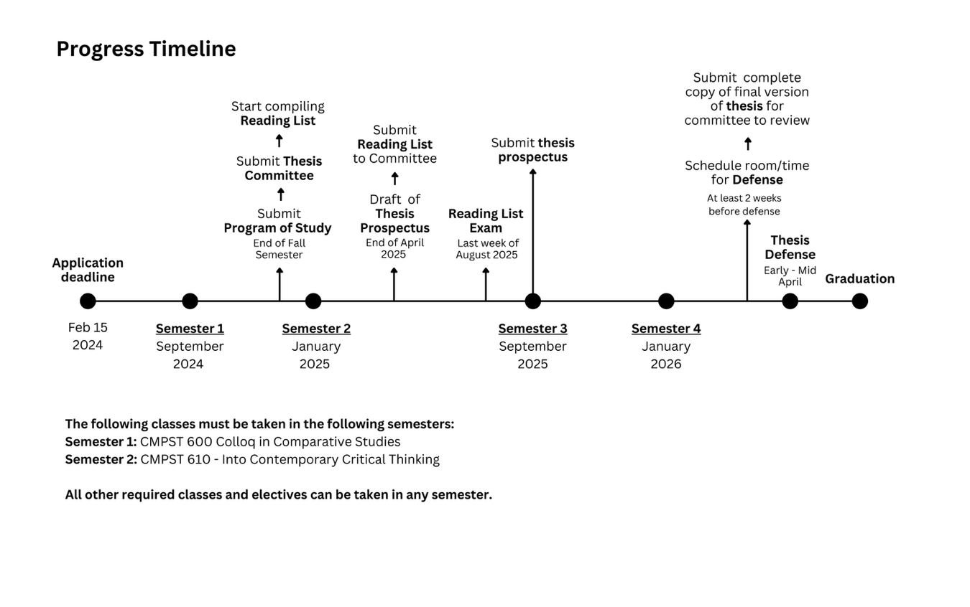
Students must be registered for at least two hours of credit during the semester or term in which they complete the degree. If you interrupt your studies before graduation, you must pay a continuous registration fee equivalent to tuition for six hours during the year or obtain approval to discontinue the program and then seek reinstatement. All work for the M.A. degree must be completed within five years.

ADVISEMENT

Graduate Coordinator

Mike Pope, 3043 JFSB, mike_pope@byu.edu

The Graduate Coordinator will send out inquirires to each student’s committee chair twice during the year to determine the progress of the student and give an evaluation.

Duties of the Graduate Coordinator
  - Receives new graduate student applications
  - Maintains files and information on all graduate students
  - Monitors status and progress of graduate students
  - Advises students on choosing thesis committee members and appoints the chair and committee members in consultation with the student
  - Distributes grants, scholarships and awards in consultation with the Graduate Committee

Graduate Council for Comparative Studies for the 2024-2025 Academic Year

The graduate program is administered by the graduate council and the graduate coordinator, both in consultation with the department chair, and assisted by the graduate program manager. Upon entering the program, the student will be assigned an advisor by the graduate council. The advisor’s principal tasks are to answer questions regarding the program, to consult about the student’s program of study, and to advise the student as needed in choosing specific courses to take. The graduate council acts as the student’s graduate committee until the thesis is begun; thereafter the student’s thesis committee and chair become the student’s principal advisors. The student must consult with their chair at the beginning of each semester to approve the ongoing program of study and assess their progress toward graduation. Graduate Studies requires two formal evaluations of every student’s progress in the program each academic year. Please see the following website for the University’s policies in this regard: http://gradstudies.byu.edu/page/evaluations-student-progress

Elliott Wise, Art History and Curatorial Studies, 3048 JFSB, elliott_wise@byu.edu

George Handley, Interdisciplinary Humanities, 3027 JFSB, george_handley@byu.edu

Joe Parry, Interdisciplinary Humanities, 3055 JFSB, joseph_parry@byu.edu

Laura Hatch, Comparative Literature, 3030 JFSB, laura_hatch@byu.edu

Graduate Program Manager

Lisa Johnson, 3008 JFSB, lisa_johnson@byu.edu

The Graduate Program Manager is also consulted to make sure that university requirements are met in terms of the student’s program of study, minimum credit hours taken, and other procedural issues and standards. The evaluation is then recorded online with Graduate Studies.

Duties of the Graduate Program Manager:
  - Maintains files and information on new applicants and current students
  - Works with the Graduate Coordinator and Graduate Committee in disseminating information to faculty and students
  - Works with and receives information from the Graduate Office
  - Oversees and enters acceptance, status, study lists, and committees on the gradprog system and other graduate system
  - Keeps copies of all appropriate graduate forms
  - Reserves rooms for thesis defenses and oral examinations
  - First approval of ETD (Electronic Thesis Dissertation)
  - Provides general advisement and support for students

Thesis Committee and Thesis Committee Chair

Incoming graduate students in the Comparative Studies program vary widely in their interests. When the student has decided on an area of emphasis—this can vary from a general theme or period to a possible topic—in consultation with the advisor, the student asks one departmental faculty member to chair their thesis committee and nominate two other thesis committee members. The thesis committee chair must be a full-time member of the Department of Comparative Arts & Letters. The committee should be formed as soon as possible to facilitate the direction of the student's coursework and thesis topic. The program of study and committee must be in place by the end of the student’s first semester and posted on GRADPROG. The student’s program of study and committee members can be changed at any time with online approvals under the direction of the graduate program manager in the GRADPROG system, but needs to be set initially by this deadline, as this is a university requirement. While realizing that a student's circumstances and the direction of their thesis may change, it is wise to choose carefully and thoughtfully to ensure a smoother path to degree completion, as multiple changes interrupts graduation plans. When the time comes to apply for graduation and scheduling of the thesis defense, the program of study should be fully completed to date and the thesis committee should reflect who will be participating in the final reading and editing of thesis drafts and oral defense of the thesis.
The committee chair becomes the chief supervisor of the student’s thesis work and should be thoroughly conversant in the general area of emphasis which the student has in mind. The student defines, together with the committee chair, a thesis topic which is supportable by the fields of expertise among the faculty. Besides the chair, the student’s thesis committee will include two other members. One of these members may come from another department at BYU. All members of the thesis committee must agree to serve in this capacity before the names are reported to the graduate program manager.

Although thesis committee chairs must belong to the Department of Comparative Arts & Letters, a reader on a committee may come from another department, provided that professor is acknowledged as Graduate Faculty by the Graduate School. Exceptions are considered by petition.

Duties of the Thesis Committee Chair
- Advises students on prospectus and thesis
  - Coordinates with other members of the thesis committee
  - Monitors progress of thesis
  - Ensures the student is engaged in appropriate research methods and techniques
  - Coordinates with the graduate coordinator and graduate committee
  - Helps the student to meet thesis deadlines
  - Chairs thesis defense and oral examinations

Duties of Thesis Committee Members
  - Advise and work with student on research for prospectus and thesis
  - Coordinate with the Thesis Committee Chair on student progress
  - Participates in thesis defense and oral examinations

Humanities College Graduate Administrator (Leslee Thorne-Murphy, Assoc. Dean)
  - Approves final submission of ETD
  - Provides college deadlines (slightly earlier than Graduate Studies deadlines)

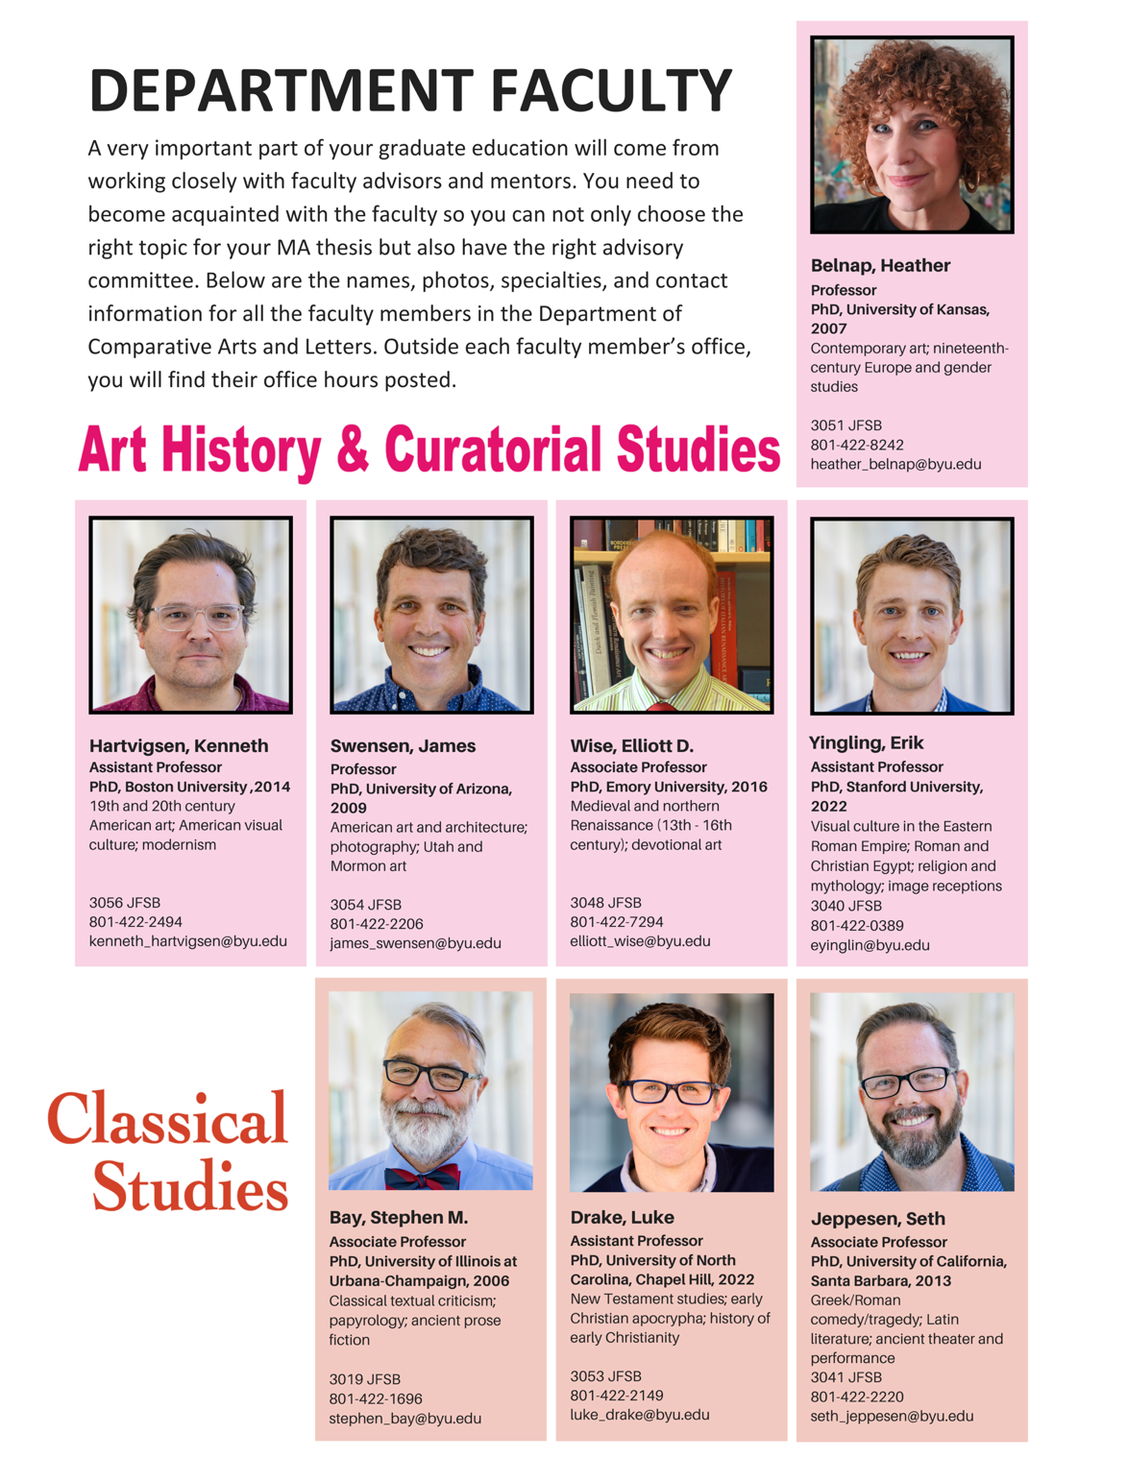

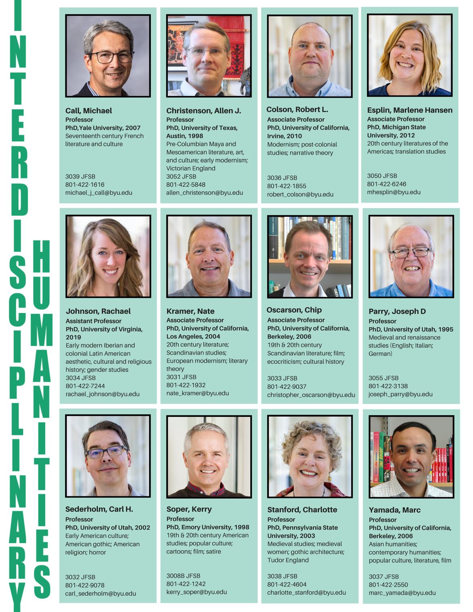

FINANCIAL AID

The Graduate School administers some funding for students, as detailed on its website. The Department of Comparative Arts & Letters can help fund costs of graduate studies through supplemental awards, teaching opportunities, and research assistantships.

Graduate Supplemental Awards
Some money is available each year for tuition supplemental awards. For Fall and Winter semester, students registered for at least six hours of credit during the academic year will be considered for a partial- or full-tuition award. The amount of the supplemental award is determined by available resources and the applicant’s merit. For Spring and Summer terms, however, there is not always money available for awards. Supplemental awards are usually not available to students after they have earned 24 hours of course credit and 6 hours of thesis credit or after two years in the program.

Teaching Opportunities
For advanced students, some student instructorships may be available. Upon admission to the respective programs, candidates will be considered for all of these possibilities based upon merit and availability of department resources. Financial aid is normally limited to two years.

Research Assistant Opportunities
Professors in the department will, from time to time, need research assistants. Please contact individual professors to see what opportunities are available.

RESOURCES
The following is a brief description of several campus resources that may be of special help to students in the Comparative Studies program.
Class schedule catalog
Graduate Studies CAL catalog page

Harold B. Lee Library (HBLL)
The HBLL is a main resource in research. You should familiarize yourself with the special features offered. If you did not complete your undergraduate program at BYU, there is an online tour of the library here.

The library provides a number of special services for graduate students. Some study carrels are available by assignment to graduate students (doctoral students have priority), and graduate students may check out circulating books for eight weeks rather than two (the undergraduate limit). Furthermore, research personnel in the library, in addition to reference desk staff, will work individually and in depth with graduate students on their research projects and theses.

Humanities Reference Specialists
If you need help with scholarly journals, periodical articles, images, and web resources, contact a Humanities Reference Specialist at the HBLL. They are experts in their fields, and this is an excellent resource for help with your research.

ART HISTORY: Cassandra Belliston Schedule an Appointment

CLASSICS: Robert L. Maxwell Schedule an Appointment

COMPARATIVE LITERATURE: Robert Means Schedule an Appointment

HUMANITIES: Mary Chapman (through Dec 2024) Schedule an Appointment

Elizabeth Smart (beginning Jan 2025)

Broader list of Humanities Reference Specialists at the HBLL

Research and Writing Center
The Research and Writing Center is a great resource to find assistance with research and writing. The center has Graduate Writing Consultants (GWC) specifically designated to support graduate students in their professional development as writers. You can make an individual appointment by going here. For more information on the Center, check out the graduate section of their website here.

Grad Pace Program
The Research and Writing Center has a Grad Pace Program where graduate students working on longer writing projects can meet with a GWC over several different sessions. The graduate student will be paired with a GWC for recurring consultations throughout the semester to help keep them on pace to meet their writing goals. An application must be submitted to be considered for the Grad Pace Program. You can find the application here. The priority deadline for fall 2024 is August 26th.

Thesis Writing Camp
The Research and Writing Center has partnered with Graduate Studies, the BYU Research & Writing Center to offer a free Thesis Writing Camp each semester to provide space, food, support, and camaraderie for graduate students as they plan, write, and revise their theses. The day camp will be held on Saturday, September 28th. For more information and the schedule, view the webpage here. If you would like to apply for the camp, apply here.

Software Training

Learn to use software from Adobe, Microsoft, Excel, and others. The library offers classes free as a library service. You can access the schedule for software trainings here. The library holds an Electronic Theses and Dissertations class which is a 1 session (1 hr) class where you learn all the tools to format your Electronic Thesis & Dissertation (ETD).

Interlibrary Loan
This service allows students to borrow books from other institutions. Photocopies of journal articles may be obtained for photocopying costs. Inquiries as to books and materials through the Center for Research Libraries (page 11 of the BYU Graduate Catalog gives details) are handled by the Interlibrary loan office, this allows for access to primary materials.

Editing Help

If you need editing, formatting, proofreading, transcription, indexing, cover/page design help, you can receive help from the Faculty Publishing Service, 4092 JKB, 801-422-1719. For more information on the here

Publishing

Students are encouraged to work at contributing articles to the scholarly community which will inform and benefit the disciplines of the arts and literature specifically, and humanity generally.

Writing and publishing, as well as conference participation, help you know and become known by others working in your field of interest. Writing papers for conferences and publication helps you learn of past and current scholarship, clarify and practice various methodologies and theories, and contribute to ongoing scholarly discussion.

Find several BYU publishing opportunities here.
Find several BYU writing contest opportunities here.

CONFERENCES
Students are also encouraged to participate in conferences dealing in their particular areas of interest. As mentioned, these conferences provide students with the opportunity to learn of past and current scholarship, clarify and practice research methodologies, and contribute to ongoing scholarly discussion while helping them get to know others working in their field of interest. Committee members can be helpful guides and resources for selecting conferences.

Students have an opportunity to apply for funding. The College of Humanities offers funding for graduate students (up to $500) to travel to conferences when they are presenting, and the department will fund up to $1000 in addition to the College funding. The funding request form can be found here. The request form has a checklist of steps to complete. All items on the checklist must be followed in order to receive funding. This funding will be a reimbursement. Students must pay for their trip, go on the trip, bring all receipts to the College of Humanities Office (4002 JFSB) within 30 days of travel, and if all looks correct the student will be reimbursed per the amounts the college and department has approved. Keep in mind —If a student wants funding to go towards a flight, the flight MUST BE purchased through BYU Travel, no exceptions.

Additional Professional Presentation Awards are available twice a year from Graduate Studies. For more detailed information go here.

